Index of Difficulty Measurement for Handedness in Human Computer Interaction

Kathleen Brush, Aditee Verma, Sadida Siddiqui, John Sheridan, Avery Leider and Charles Tappert

Seidenberg School of CSIS, Pace University, Pleasantville, New York

{kb31851p, av11813n, ss05380p, js58363p, aleider, ctappert} @pace.edu

[1]

*Abstract*—Three touchscreen experiments are developed in Flutter and conducted to determine whether the results vary significantly due to laterality. Data is gathered from an equal number of right-handed and left-handed participants for each trial. The first experiment involves an extension of a Fitts’ Law experiment, while the other two use Steering Law to measure index of difficulty. The data collected is analyzed to see whether they correspond to a mirror difference between right-handers and left-handers. Data from each participant is also analyzed via machine learning and data visualization to see whether the data from the native touchscreen and timing features provide reasonable biometric authentication information.

*Key terms*— Authentication, Biometrics, Cross-platform, Fitts’ Law, Flutter, Human Computer Interaction, Laterality, Machine Learning, Steering Law.

# INTRODUCTION

*A. Background*

Touchscreens on laptops, tablets, and mobile phones are obscured by left access points. Interfaces are designed for the right-handed. It is currently estimated that 91% of humans are right hand dominant and 9% are left dominant [6]. While cursor controls such as mouse buttons and touchpads can often be reversed in setup, with direct finger on screen interaction, the hand and forearm can get in the way of information on the display screen. There is very little public awareness of left-handed accessibility issues and accommodation in UX/UI and HCI, human computer interaction.

Fitts’ law calculates the time to click a point on the screen as a function of the distance traveled and width of the target. It is used in HCI to design UI/UX of mobile apps. Using time, distance, and width the difficulty coefficient can be calculated. In the following mathematical equation, 2 ( ), where *MT* ***=*** movement time,*A* = moving range, and *W* = breadth of the target [2]. The Index of Difficulty, 2 ( ) is also called the difficulty coefficient and is represented by ID.

Fitts’ law predicts movement from one location to another. It has been concluded in another study that the screen quadrant measured most difficult to access should be avoided when designing touchscreen apps [2]. However, if one is using the left hand, this display area may not be difficult to access. This research extends the study by Zhang, et al. to include both right-handed and left-handed participants performing the experiment using each hand in succession. Hypothesis one is that there will be an equal and opposite, or mirror difference for right and left-handed subjects.

Steering Law, derived from Fitts’ Law will be used to calculate accuracy. This law is a predictive model of subject movement that describes the time required to navigate or steer through a tunnel. Below is the mathematical equation where A = length of the tunnel, and W = width.” [21]. Fig. 1 illustrates this concept:

IDs = A/W,

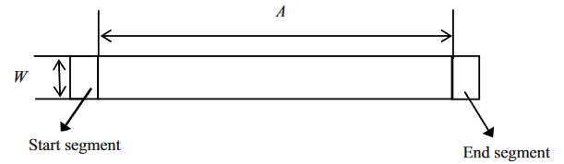

Fig 1. Straight Tunnel Steering [21]

*B. Objectives*

The purpose of this work is to experiment by developing a cross platform mobile app using Flutter to gather data points on an equal number of self-identified right and left-handed subjects. The methodology includes the following key components:

1. First experiment captures the time to reach and click a target point, distance to target point, and its width in each of the four quadrants on the display.
2. Second experiment measures accuracy via timing features and touchscreen features with dropdown menu.
3. Experiment three checks for screen visibility. Timing and response speed are addressed by designing mirror image screens asking subject to click on specified object from each image.
4. Experiments are conducted on equal number of self-identified right and left-handed subjects
5. Since the app is cross-platform, experiments are also conducted on equal number of Android and Apple devices
6. Data points are collected and stored in Firebase database in json format.
7. Data collected is analyzed to see if it yields an authentication biometric using data visualization and machine learning.

# LITERATURE REVIEW

Numerous studies have been performed in the area of keystroke analysis since its conception in 1975 at Spillane. Although the studies tend to vary in approach from what keystroke information they utilize to the pattern classification techniques they employ, all have attempted to solve the problem of providing a robust and inexpensive authentication mechanism.

One of such research carried out is “Keystroke biometric studies with short numeric input on smartphones" [3]. This study utilized keystroke biometrics to analyze the subject’s interaction on mobile phones to further enhance subject’s experience. However, unlike past researches, the study also analyzed data collected from touchscreen features such as pressure, screen location, accelerometer, and gyroscope information in addition to data collected from the usual key-press and key-release timing features available from mechanical keyboards. It involved collecting short ten-digit numeric strings from 52 participants on identical Android smartphones. The same number was used by all participants to avoid bias and to allow each participant’s data to be used as imposter data for the other participants. The feature types were broken down into keystroke (timing features only), touchscreen (mobile sensor features only), and combined (both timing and sensor features) to study which category yields more pronounced result. It involved performing several user authentication biometric experiments to measure overall system performance and to quantify the biometric value of various feature subsets.

Two different validation methods: Repeated Random Sub-Sampling (RRS) and Leave-One-Out cross-validation (LOOCV) were compared in the study and, as expected, the LOOCV method provided better results than RRS but at the expense of greater computation time. Of the two distance- metrics compared, the Manhattan distance outperformed Euclidean distance consistently throughout all the experiments, regardless of the feature set used. The performance of the traditional timing key-press/key-release features was considerably worse in this study (about 20% Equal Error Rate (EER)) compared to performances reported in earlier studies on mechanical keyboards (e.g., 8.6% EER [10] and 6.1% EER [9]). On the other hand, the excellent results achieved by the touchscreen features (4.0% EER) and the gyroscope only features (4.3% EER) appears to offer a compelling approach towards user authentication on smartphones.

The recent paper “A Survey on Keystroke Dynamics Biometrics: Approaches, Advances, and Evaluations,” [8] compares and evaluates different machine learning models and their combinations, the distance matrices and the types of datasets available for the keystroke biometrics analysis. Digraphs, which are the time latencies between two successive keystrokes, are commonly used. Some of the earlier studies performed analysis using T tests, means and variances on Digraphs. Different distance matrices and machine learning approaches utilized for keystroke analysis are listed in table I.

Table I. List of different distance matrices and machine learning approaches utilized in the past for keystroke analysis [12], [20], [16], [18], [14], [11], [10], [19], [17].

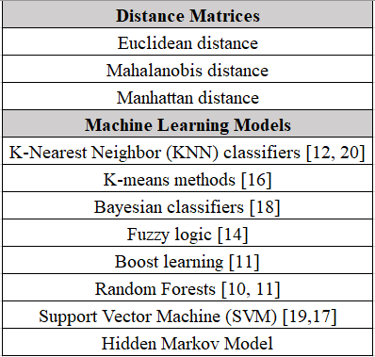

# METHODOLOGY

*A. Flutter*

A multi-platform mobile app is built using Flutter. Flutter is a product by Google which facilitates building of apps faster. This development SDK is chosen because it is open source, it creates cross platform apps and it has hot reload, meaning as soon as we make any change in the code, it gets reflected on the simulator. It uses Material Design which is the design language and it gives very aesthetic and distinctive look to the UI.

In order to use Flutter on any machine, Java Development Kit(JDK) and Android Studio are required. GitBash and Visual Studio code are the two additional softwares used to work on Flutter. Running commands through GitBash makes it the operations smooth and the code editor used is Visual Studio. Android Studio can also be used as a code editor. But either ways Android Studio is important to be installed because it contains the emulator which is required to run the app on Windows. Mac users can use Visual Studio as the code editor and Xcode simulator to run the app. After installing Flutter, the global environment path of the machine has to be set, which basically enables the user to run Flutter in any directory. If the global environment variable is not set, then the path has to be set every time a new terminal is launched or working directory is changed.

There was a lot of troubleshooting done while setting up Flutter and working on it. Find some of them listed below:

1. Android Studio requires a good amount of Read Only Memory(RAM) to run the simulator. This issue was tackled by using a real device to run the app.
2. The configuration files of Flutter cannot reside in directories which require elevated permissions. Hence Flutter was installed on “Desktop”.
3. Android Studio simulator has to be up and running to run the Flutter project. There are dependencies associated like “Jcode” and “Google” which helps to build the project. Changes were made in “Build.gradle” file which resides in the Flutter installation files to fix the build errors.
4. Flutter apps are written using the language Dart, which is new and not much people are familiar with it. Hence it took some time to understand it and the layouts in Dart are one of the challenging areas.

*B. Designing Experiments*

For designing the wireframes of the mobile app, Mockflow, which is an online wireframe tool is used. Monthly subscription of this tool costs around $20. All the screens were first created using Mockflow and then reviewed by the client and were further improved. Finalized wireframes were then developed using Flutter.

The home page of the mobile app is designed to ask the subject to select whether their dominant hand is right or left as shown in Fig. 2. Researcher will observe that subject is navigating with the declared hand.

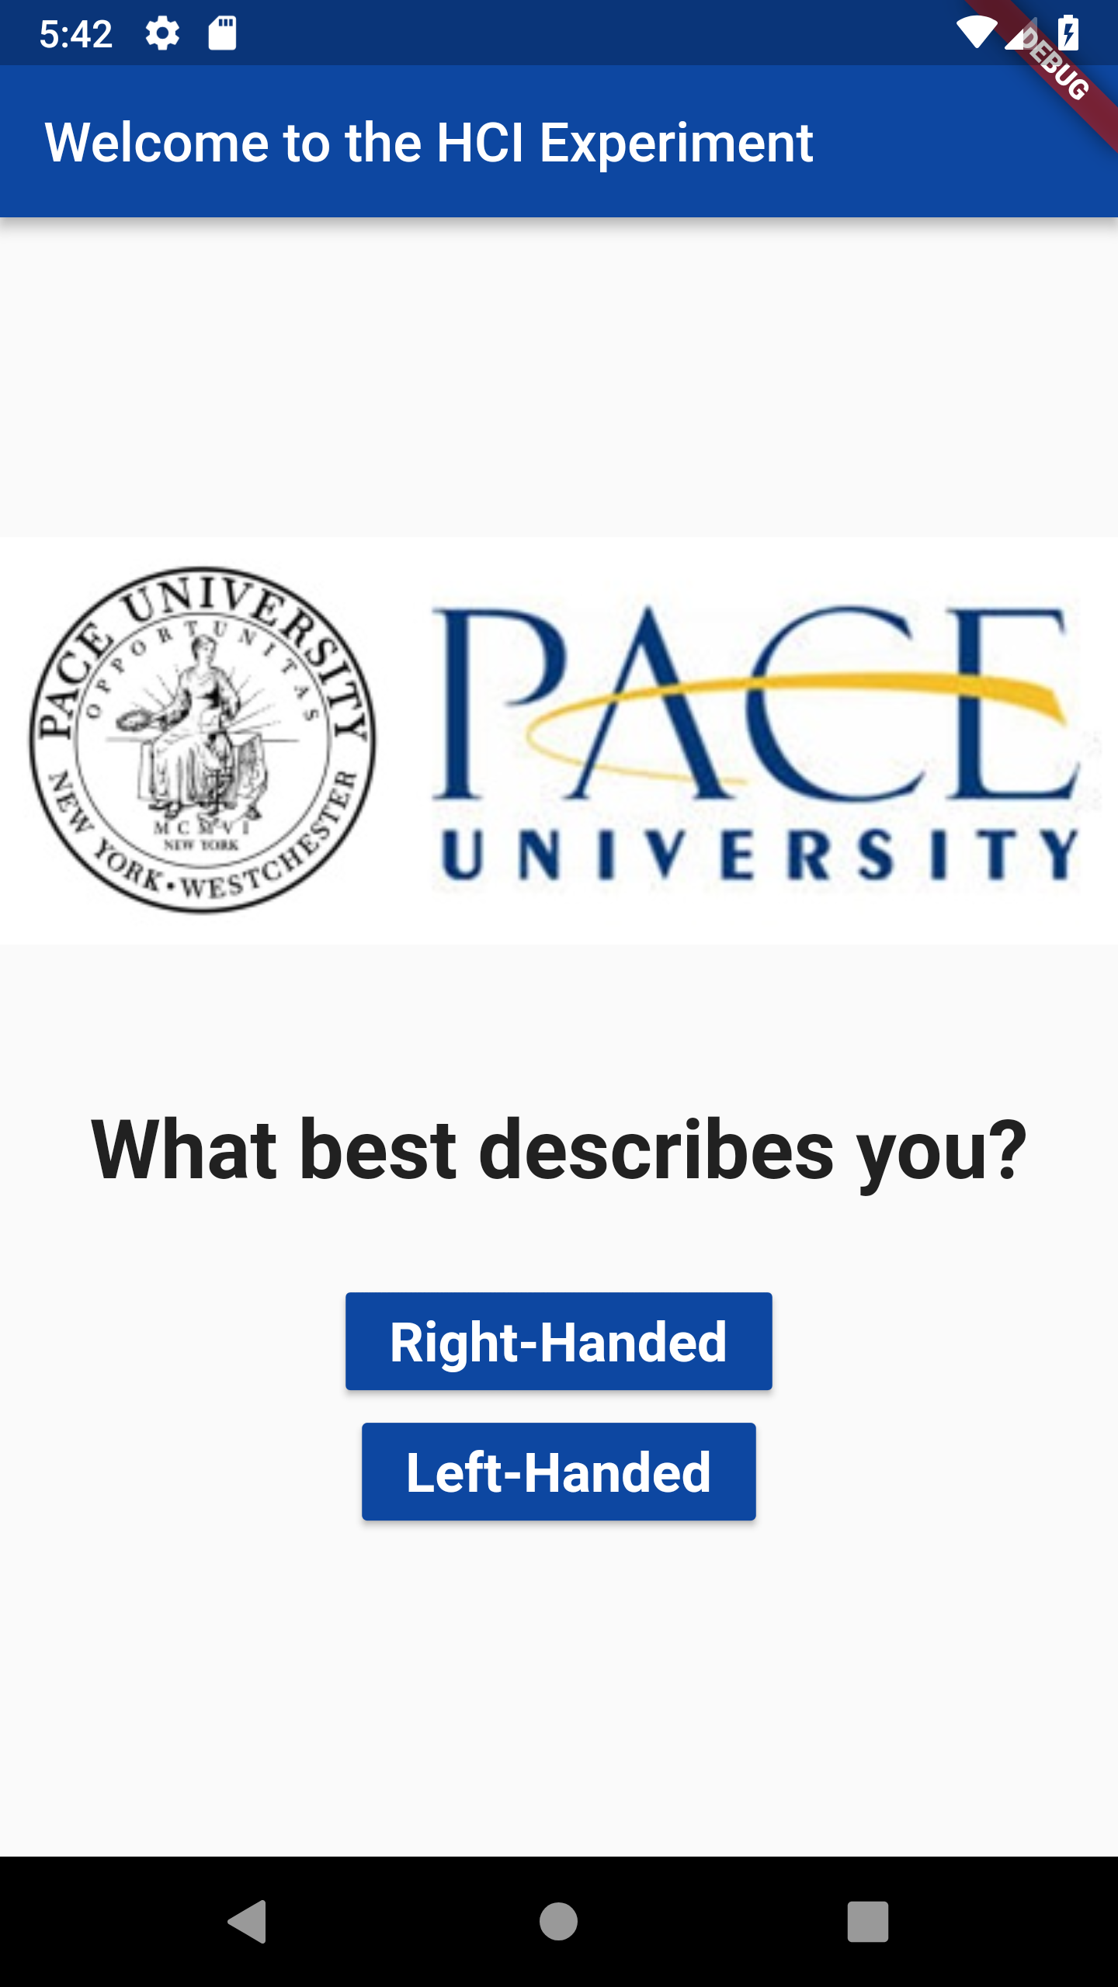

Fig. 2. Home Page or the landing screen of the mobile app asking the subject to select their dominant hand.

Subject is asked to make the movements at their usual pace. The study requires the subject to complete all the experiments using the dominant hand first and then again using the non-dominant hand. It is required to collect this data so that there is sufficient data to analyze how differently a subject functions using both their dominant and non-dominant hand. Data is also collected on both Android and Apple devices in order to determine how differently the subject functions in different environments.

Before every experiment the subject gets an instruction screen explaining how to perform the experiment. After the three experiments are completed, another screen guides the subject to use the non-dominant hand and complete the experiments again. The mobile devices’ native sensors for pressure, screen location, accelerometer, and gyroscope information which would facilitate the capture of data points to be measure while performing the experiments are also activated.

The three experiments are described in detail below:

The first experiment determines the difficulty coefficient by using time to reach and click a target point, distance to target point, and its width in each of the four quadrants on the display. There are eight target points, each 250 pixels from the start point (0,0) at 45-degree clockwise rotation intervals as shown in Fig. 3. Only one target point appears on screen at a time. The target points are 60 pixels (a circle with a 30-pixel radius). One click task consists of clicking the start point and then the target point with a fingertip.  Then, the next screen displays. When all eight target click tasks are done, that completes one cycle test. The experiment consists of eighteen cycle tests. The first two cycles are practice sessions and not included in the analysis for each subject [2]. We are extending the experiment by including dominant hand information, as well as an equal number of right-handed and left-handed subjects. The subject will be asked to use their declared dominant hand and will be observed doing so. They will be later asked to repeat the experiment with their non-dominant hand as well. Timing features and touchscreen features such as screen location points are captured and recorded for each subject’s entire eighteen cycle tests.  Distance and width data points are entered into to the Fitts’ Law equation to measure duration. This experiment aims to prove that if a certain quadrant is difficult to access for right handed subject, it will be easy for left handed subject. Index of Difficulty and accessibility are the mirror images for each hand.

1. Accuracy is measured via timing features and touchscreen features using dropdown menus. Ideally a stair step selection menu also known as cascading menu had to be used for this experiment, but mobile apps do not have cascading menus. Hence dropdown menu is used for this experiment. First, the menu will travel from upper right to lower right. Second, the menu will travel from lower left to upper left. Steering Law, as described in background information is used to calculate the results.
2. Screen visibility, timing, and response speed are addressed by a screen with an Image followed immediately by another screen presented to the subject with additional written instructions. A mirror image of this procedure displays next.

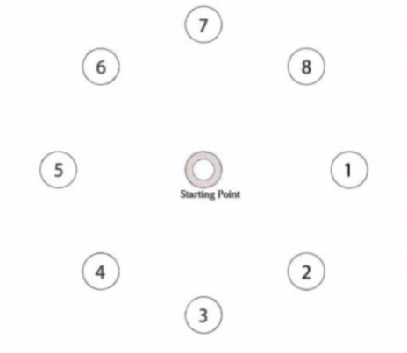

Fig. 3. Positioning of the target points on the screen [2].

*C. Data Gathering and Analysis*

The backend used in the Flutter app is Firebase which stores data in a non-relational format which is a json format. While the experiments are conducted on the subject several screen features are been recorded in the database. Table II, III and IV shows the features along with their description, collected while performing experiment one, experiment two and experiment three respectively.

Table II. Experiment One - List of Features collected along with their description.

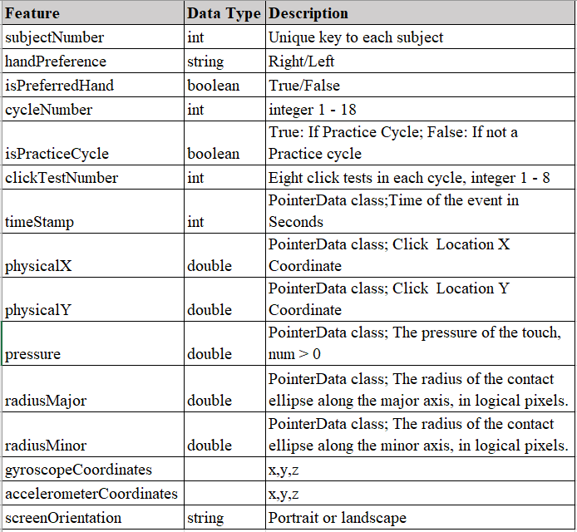

Using these features phase two of the project starts which involves performing experiments on equal number of right-handed and left-handed subjects. These experiments are also performed on equal number of Android and Apple devices. Once sufficient amount of data has been gathered, the json data files for each experiment is fed to a Python module for data visualization using Matplotlib library. After that machine learning can be further used to find the patterns in data. There are many softwares available to pick from such as Seebo, TensorFlow and Weka. TensorFlow may be the most viable option being that it is a Google product alongside the app building product Flutter. Researching the most apt machine learning approach to find patterns in data lies in the future scope of this paper and has not been started.

Table III. Experiment Two - List of Features collected along with their description.

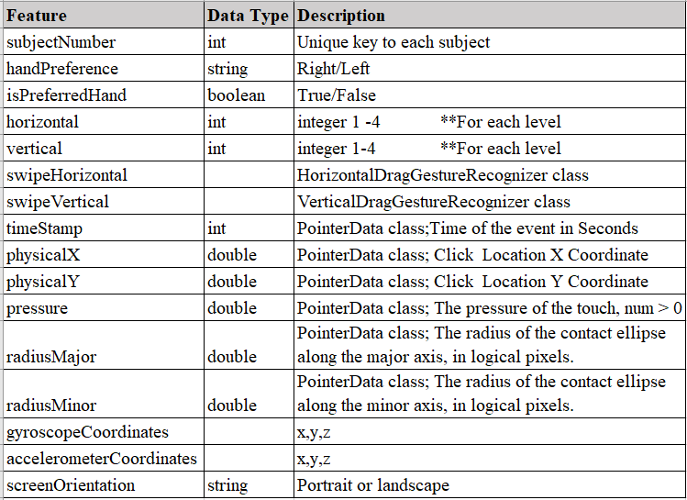

Table IV. Experiment Three - List of Features collected along with their description.

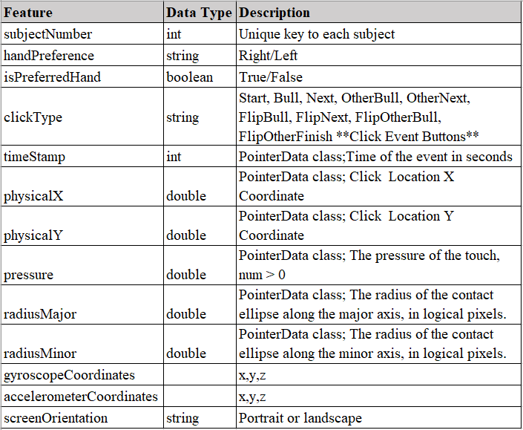

# RESULTS

At first there were real concerns over whether Flutter could be used to develop the application because Dart being a pretty new language it took some time to get started with the app, but once the basic layout was laid out, the further development and testing was quick and smooth. Fig. 4. displays the instruction screen for the experiment one, which is educating the subject that there are 2 practice cycles first and then the main cycles and making sure experiments are performed by the subjects at their usual pace. Following the normal pace is required as it can distort the data and results in faulty analysis. Fig. 5 shows how the experiment one practice cycle and actual data cycle screen looks on the app. The targets would appear randomly one after another to gather meaningful results.

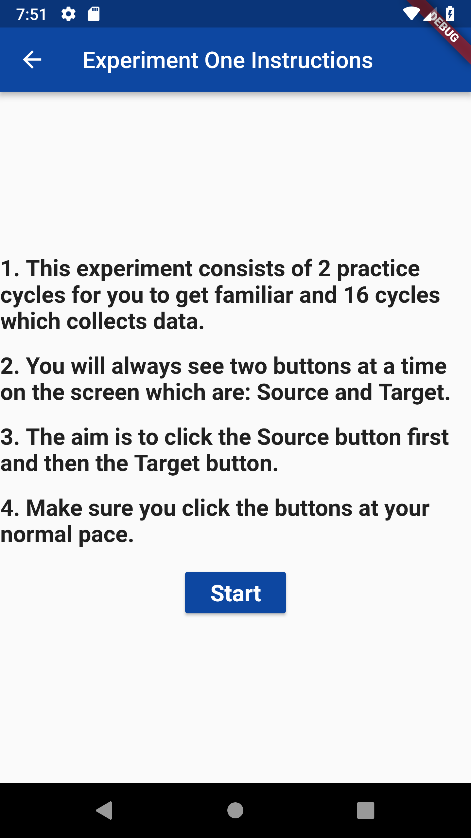

Fig. 4. Instruction screen for experiment one.

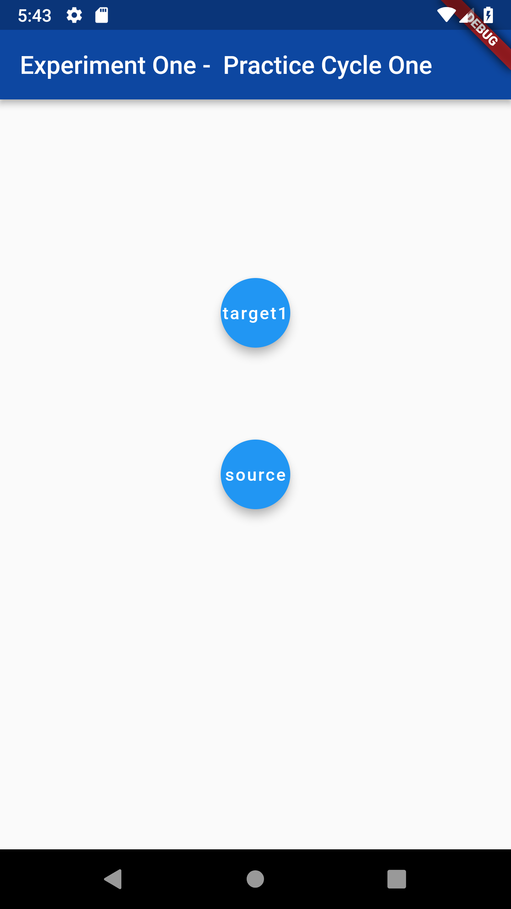 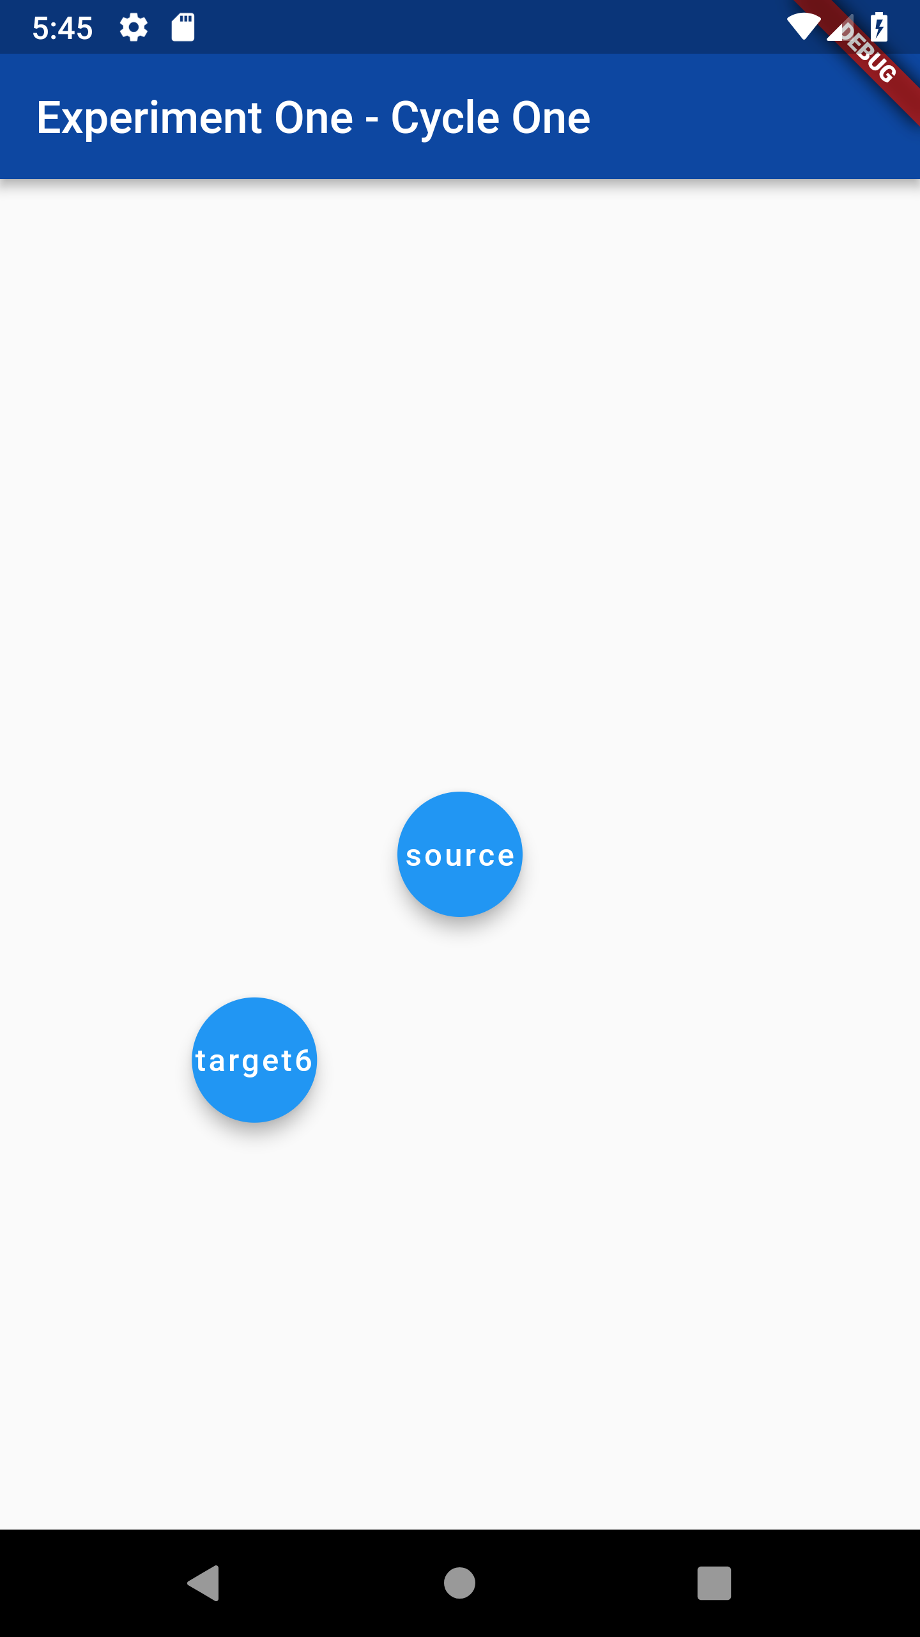

Fig. 5. Practice cycle and actual data cycle of experiment one showing targets at two of the 8 places.

Fig. 6. shows the instruction screen rendered soon after the subject finishes the 18 cycles of experiment one, the instruction screen educates the subject that they must select the specified item from the dropdown list and work on their usual pace. Fig. 7. Shows the two screens to perform the experiment two. First screen shows the dropdown displaying from right top corner and second screen displaying the dropdown coming from bottom left corner. The text displayed asks the subject to select a specified item from the list and then press the next or finish button.

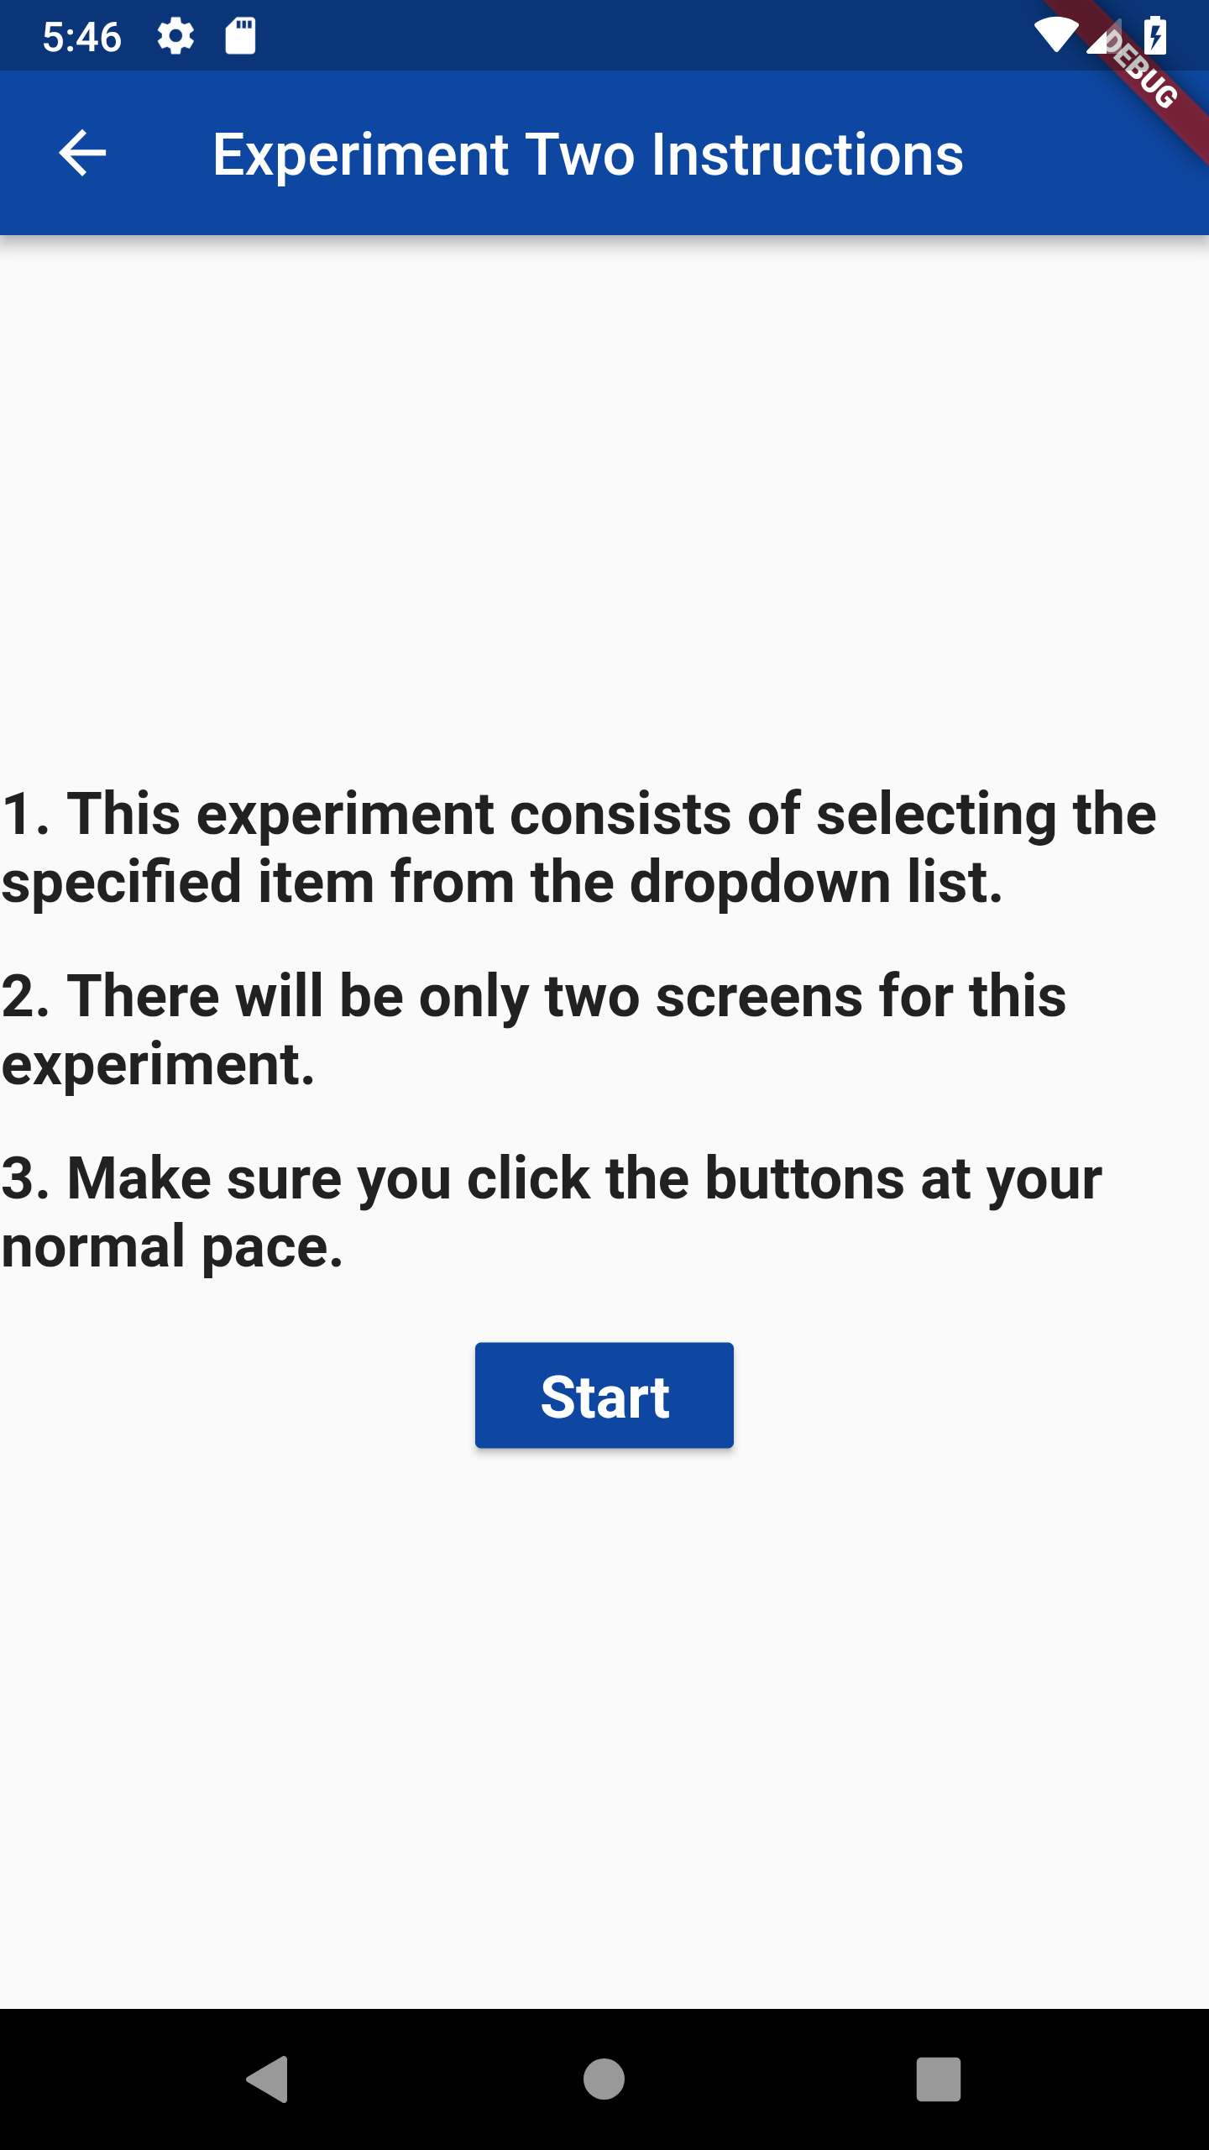

Fig. 6. Instruction screen for experiment two.

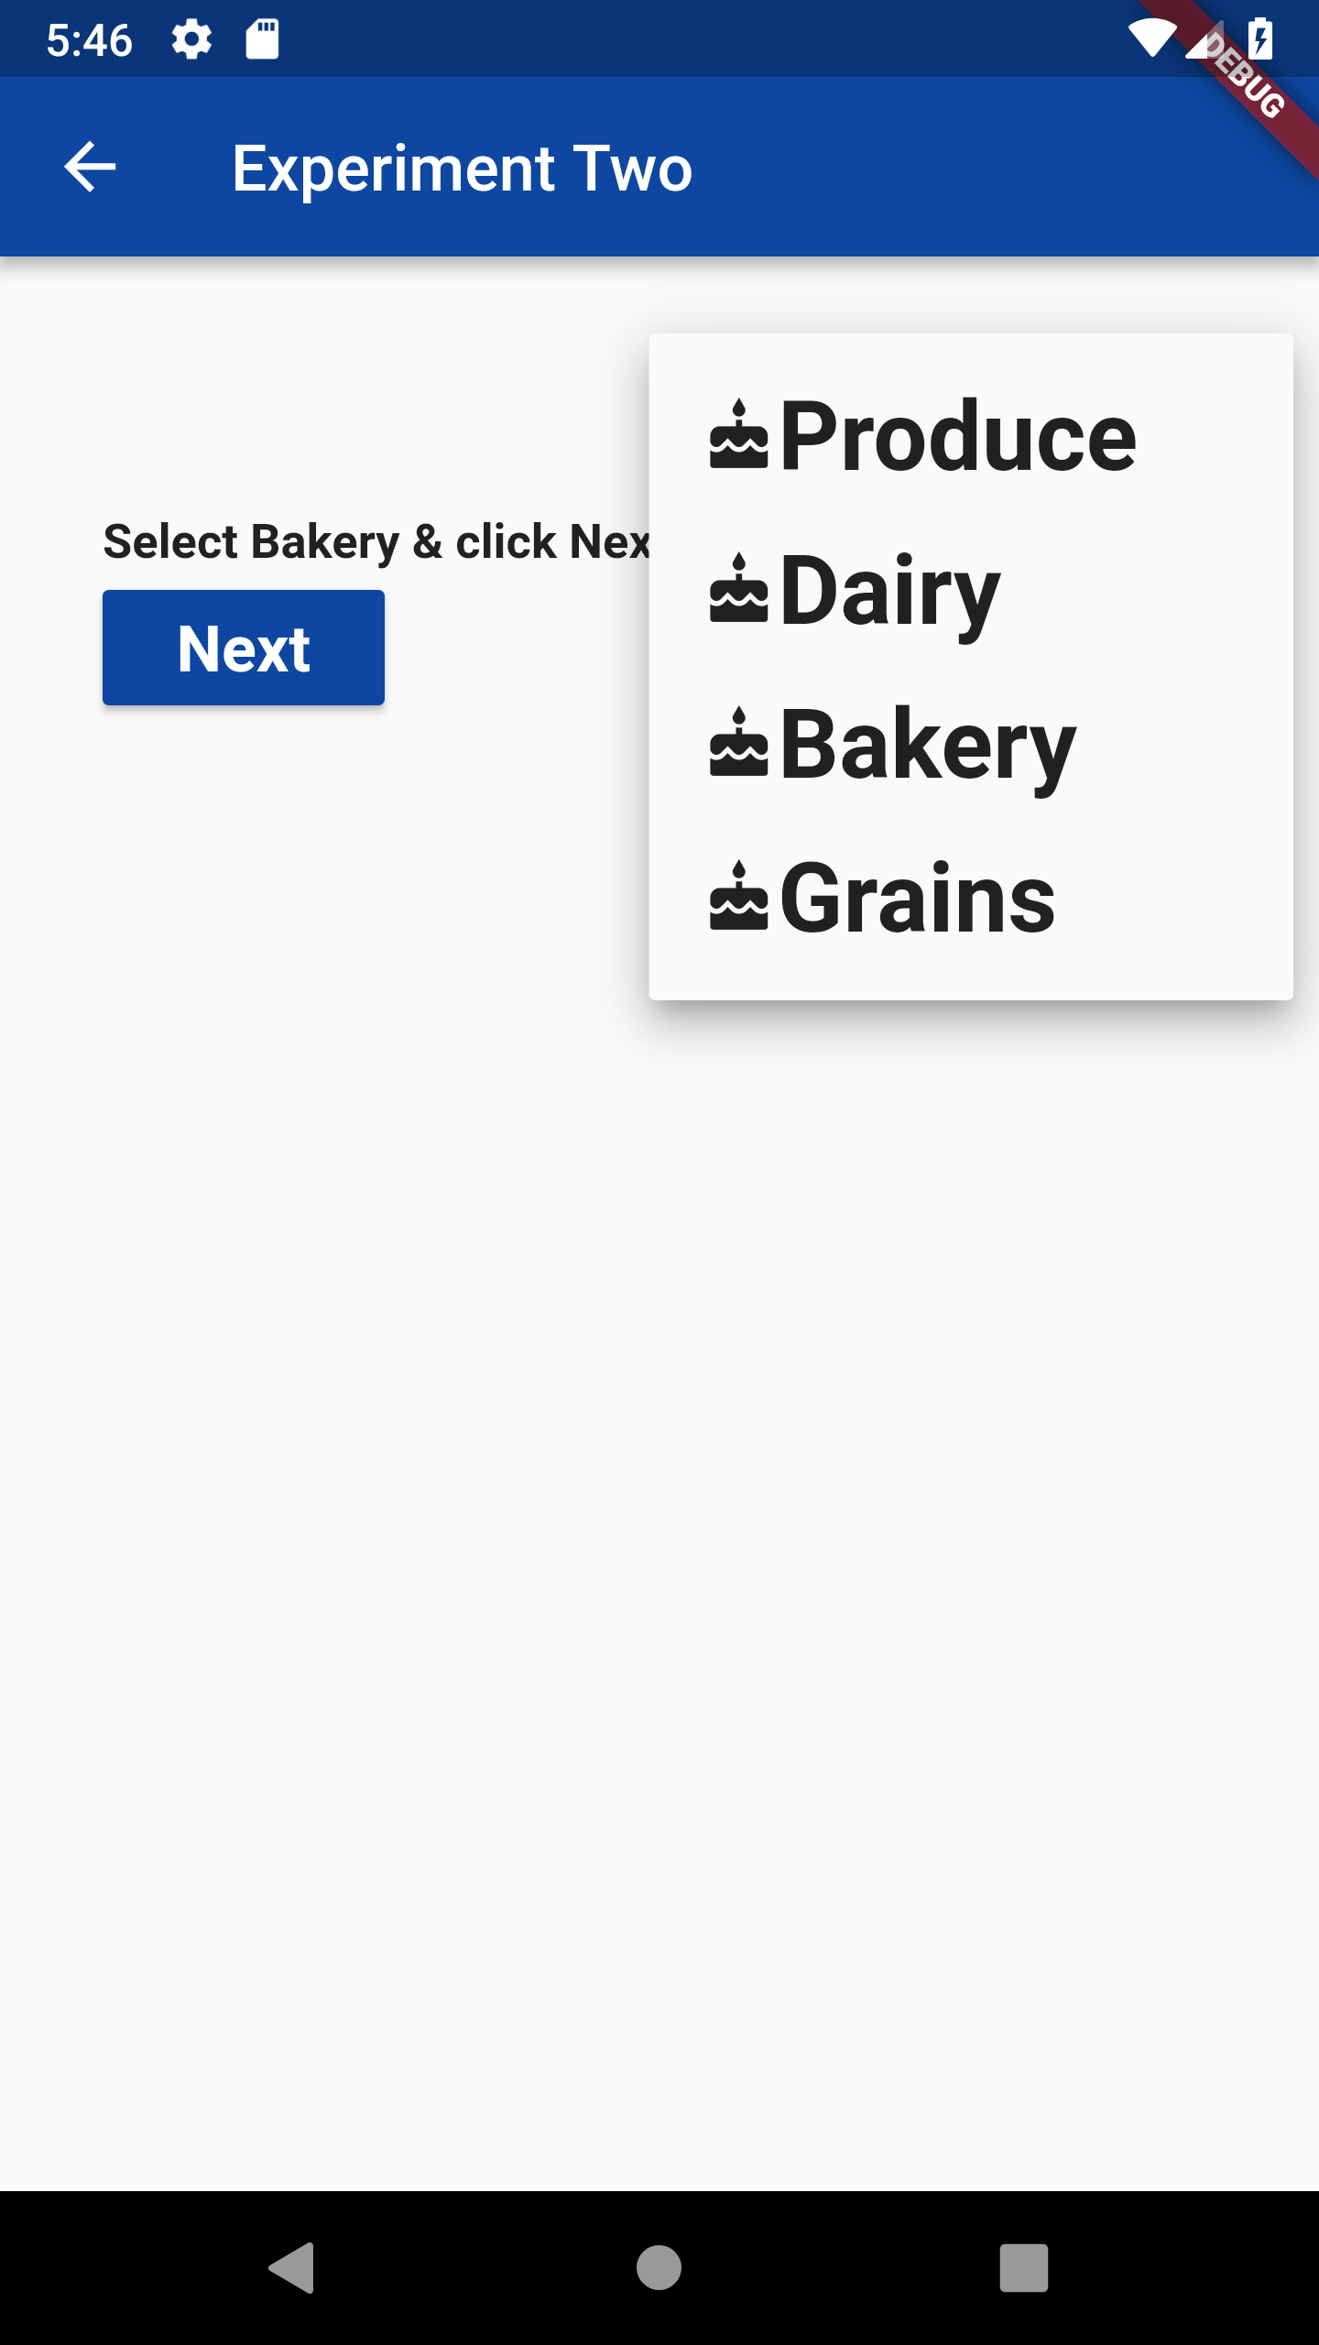 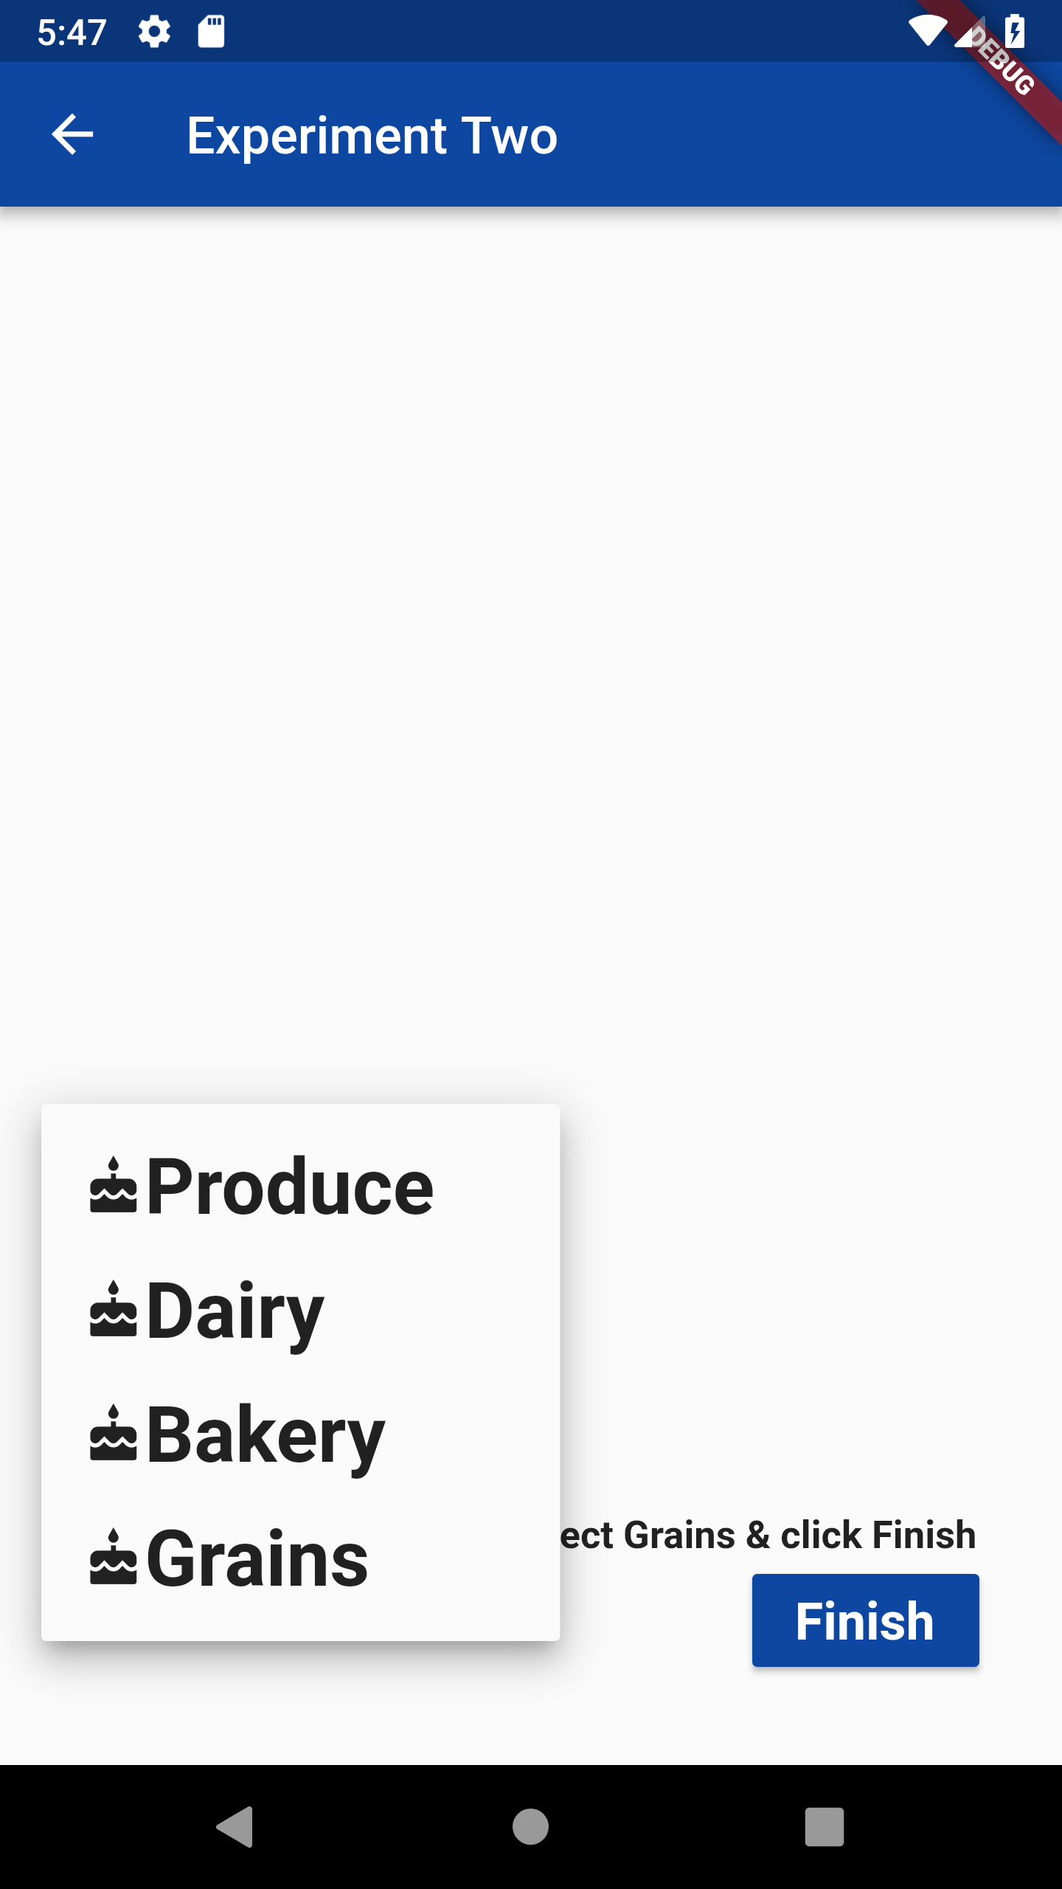

Fig. 7. Experiment Two: First screen shows the dropdown appearing on right top corner and the second screen showing the dropdown appearing on the bottom left corner.

Fig. 8. shows the instruction screen rendered soon after the subject finishes the experiment two, the instruction screen for experiment three. The instructions educate the subject to click on the specified object on the image displayed and do the operations at their usual pace. Fig. 9

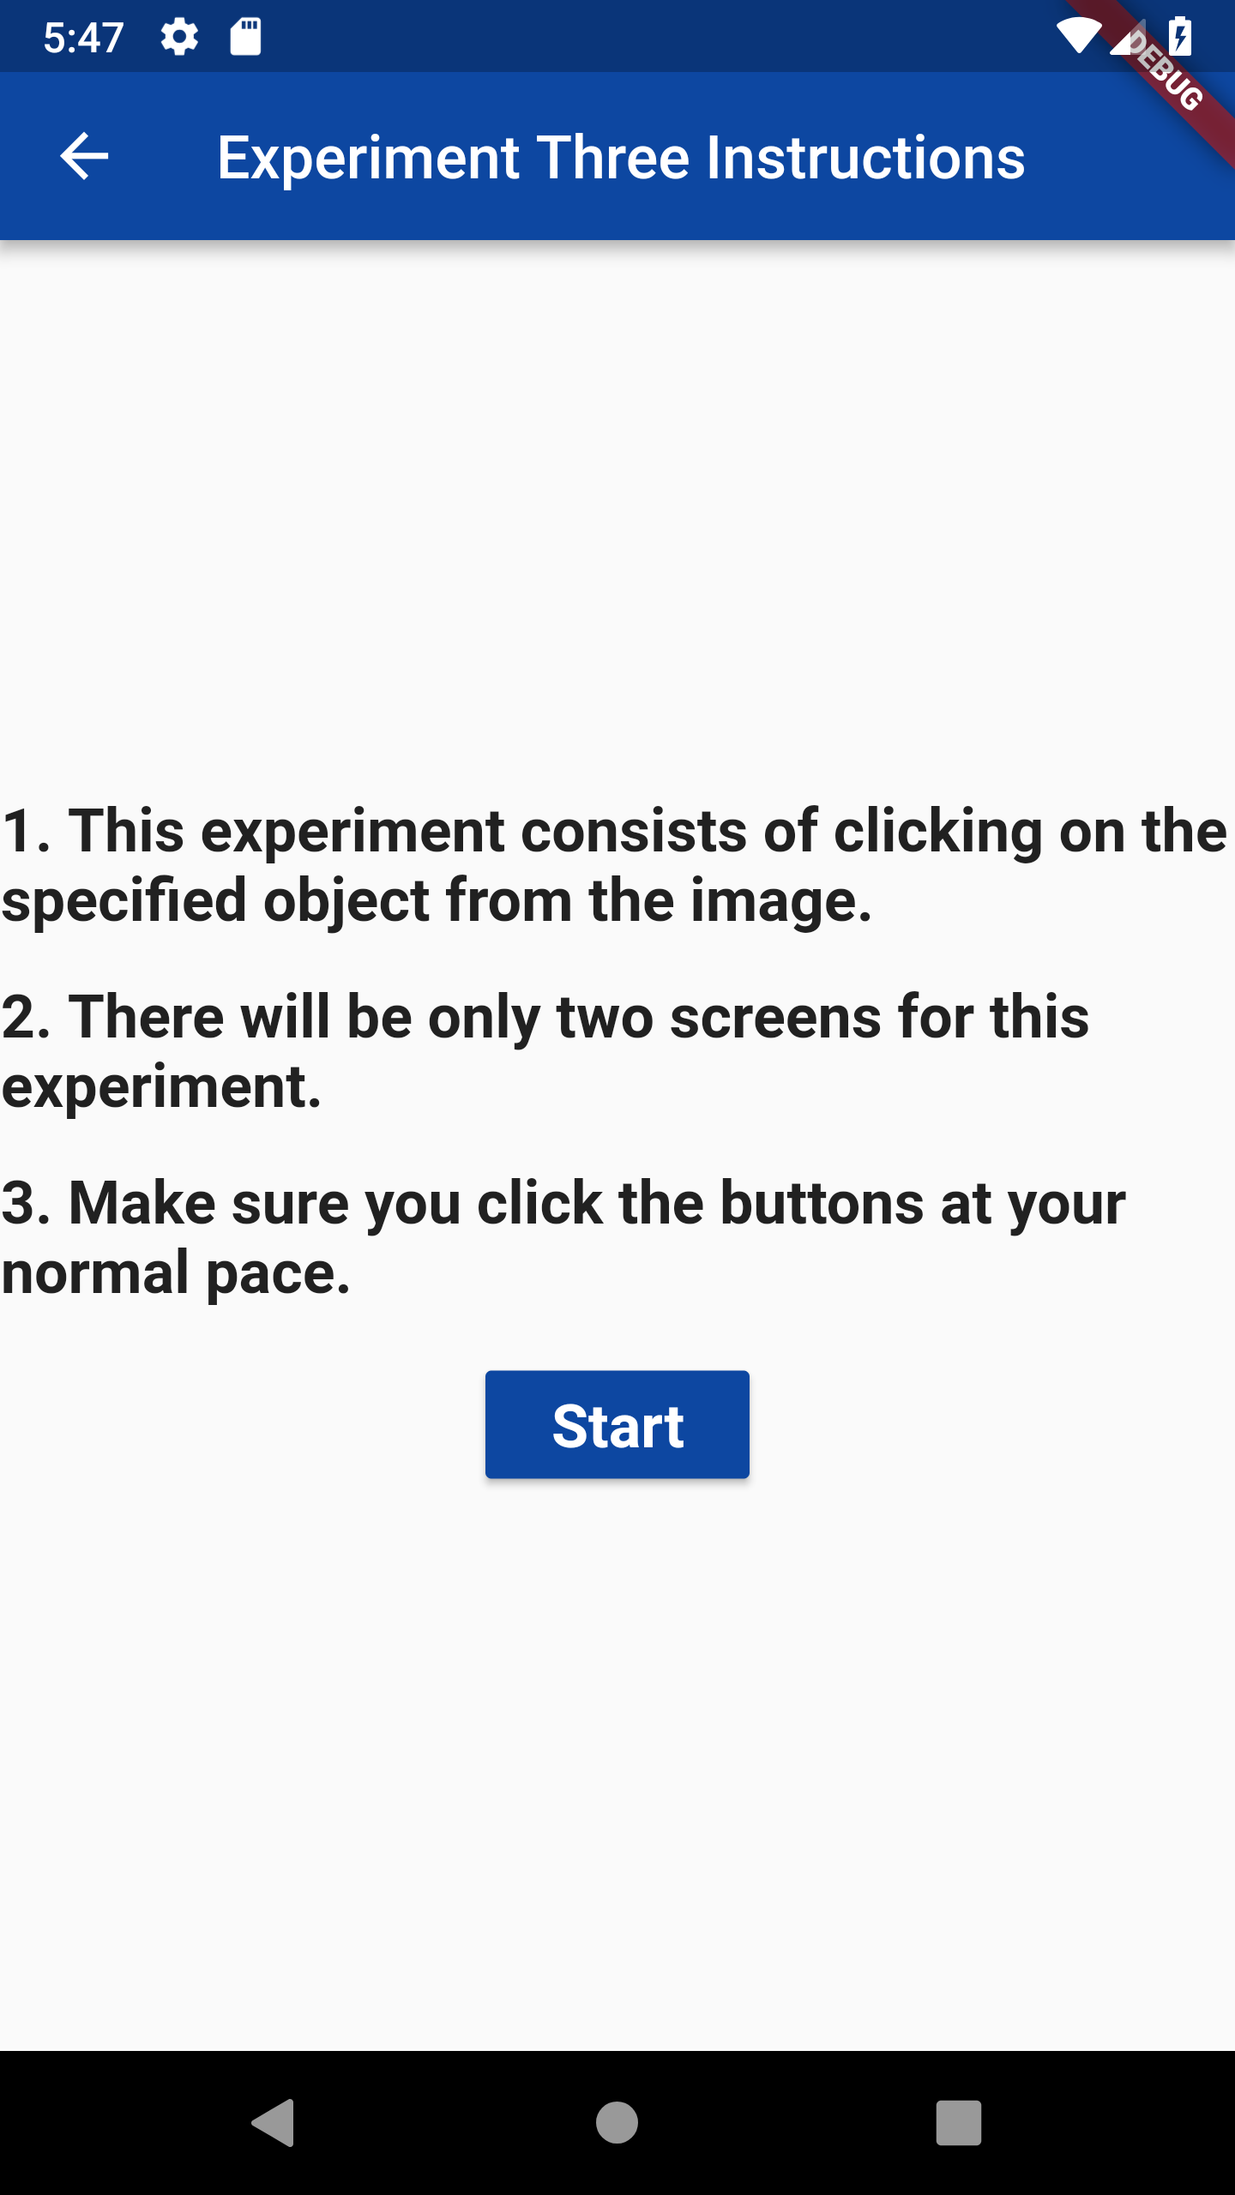

Fig. 8. Instruction screen for experiment three.

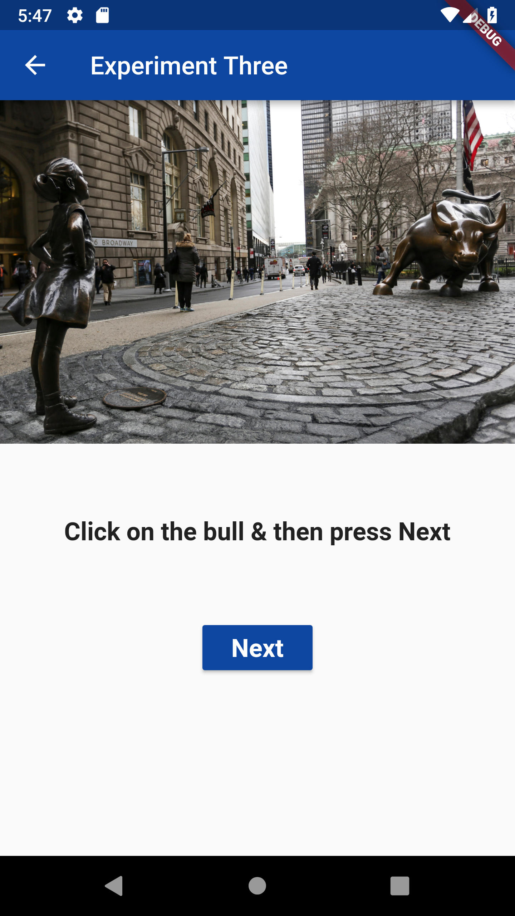 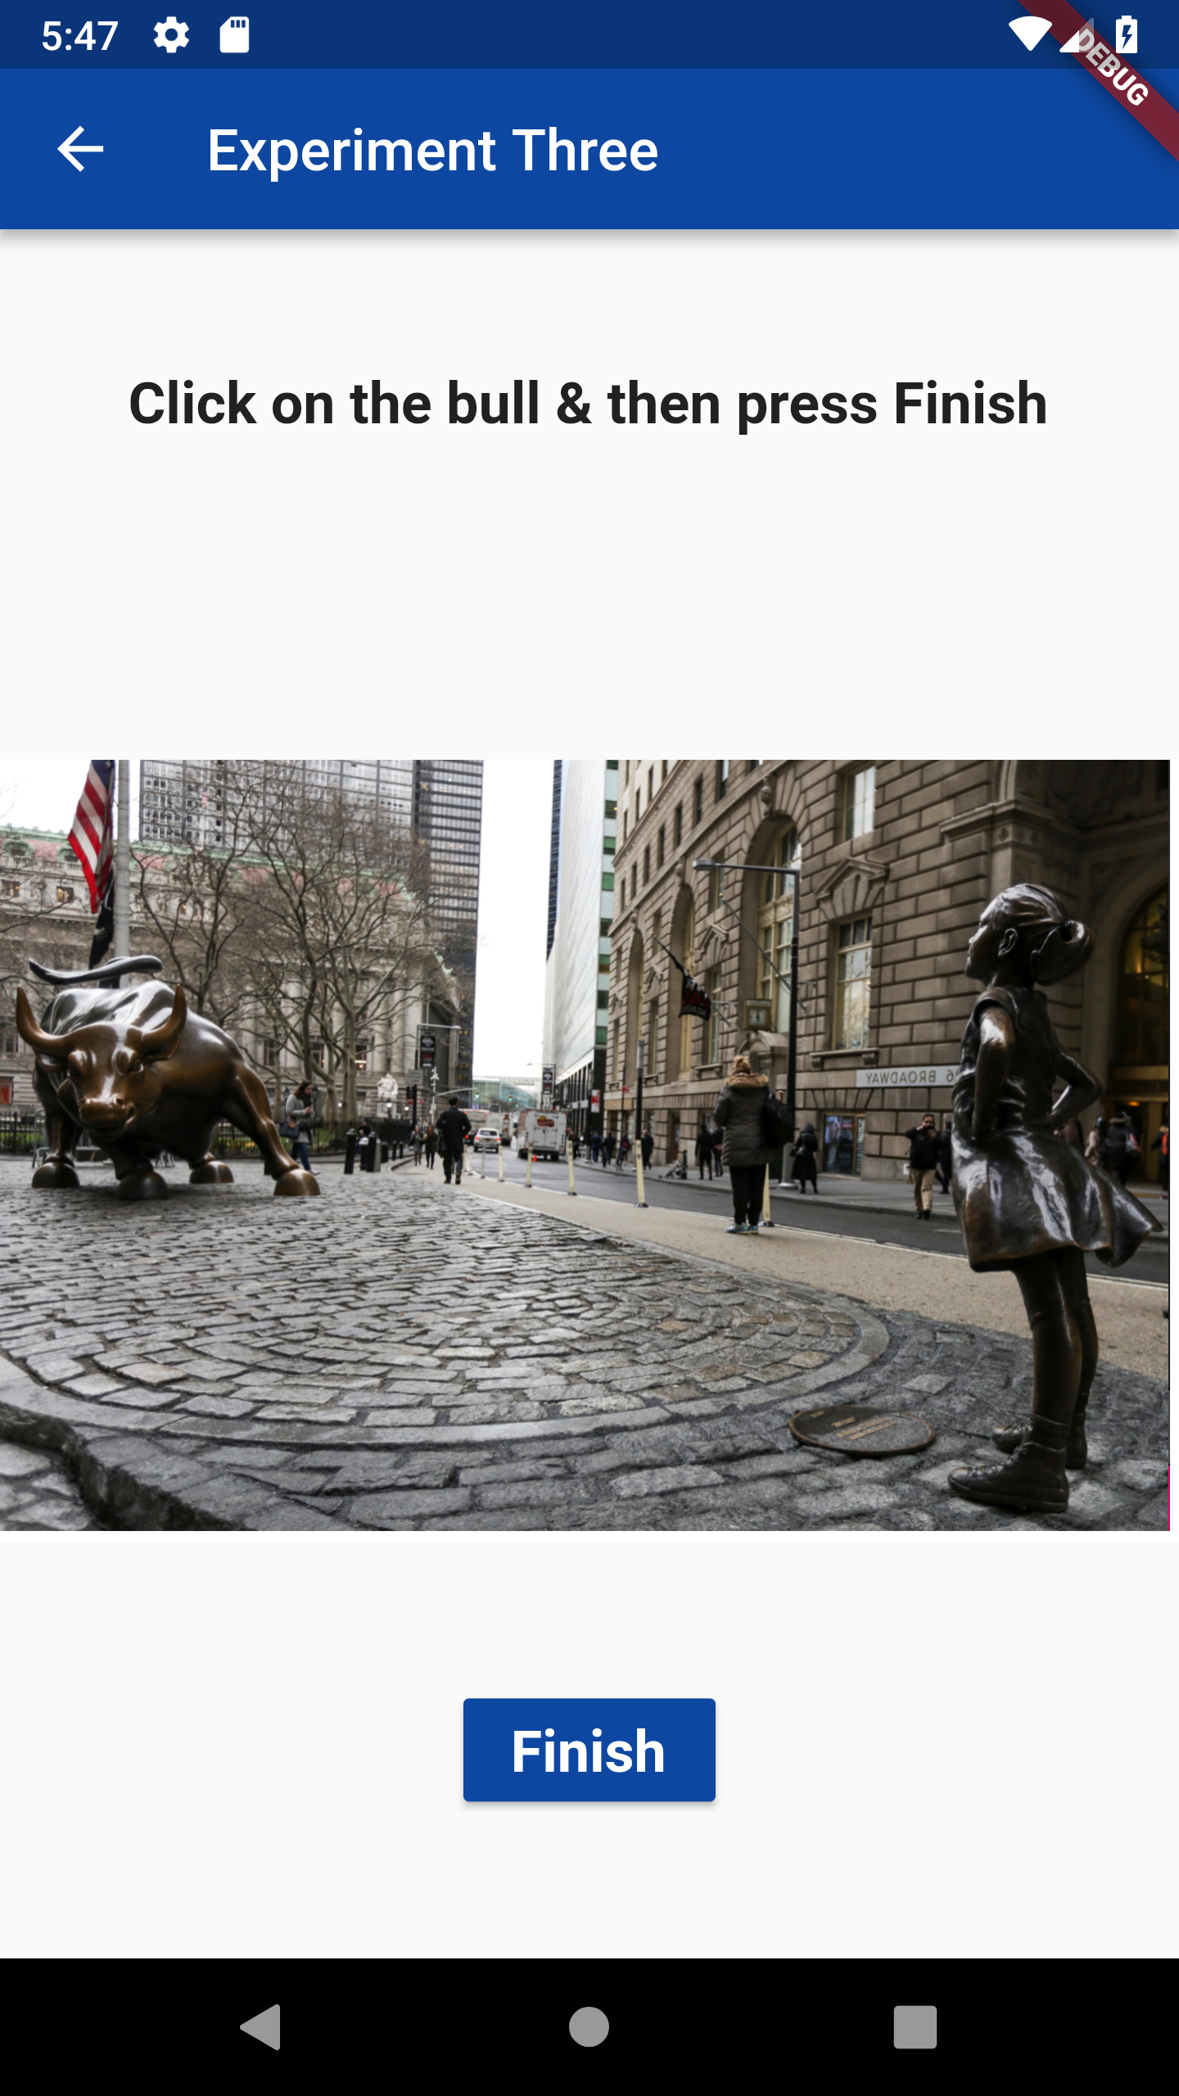

Fig. 9. Experiment Three: First screen asks the subject to click on the bull in the image and the second screen asks the subject to click on the bull again but the image is now the mirror image.

shows the two screens for experiment three. The second screen uses the mirror image of the first screen to analyze the timing lag the subject faces while clicking the right and then the left side of the device.

After all the three experiments are completed by the subject using the dominant hand, another screen which is shown in Fig. 10. is rendered on the screen to tell the subject to again start performing all the experiments using the non-dominant hand. When subject clicks on Start, they are taken to the experiment one instruction screen and the subject performs all the experiments again. The researcher

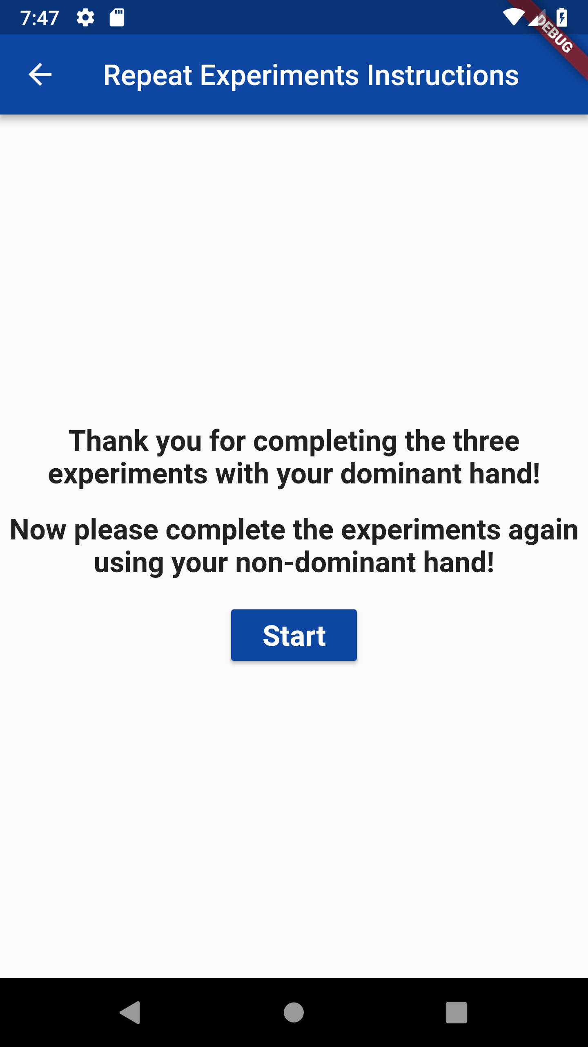

Fig. 10. Instruction screen requesting the subject to complete the experiments again using the non-dominant hand this time.

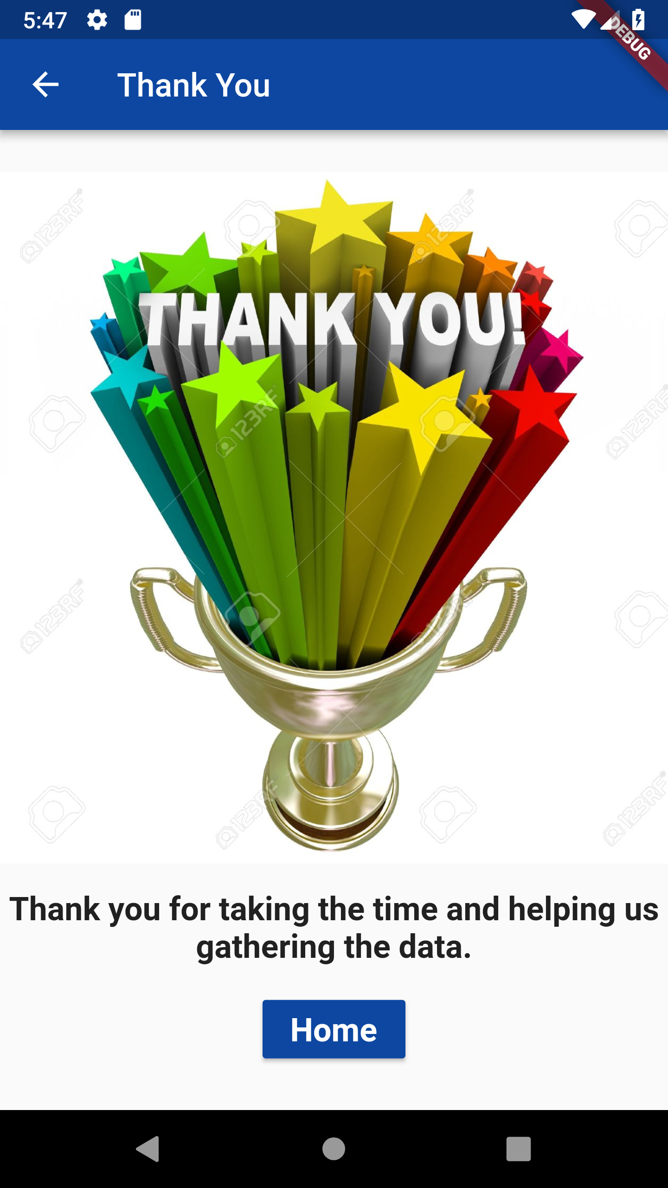

Fig. 11. Thank you screen displayed when the subject has completed the experiments using both dominant & non-dominant hand.

is supposed to monitor that the subject is using the non-dominant hand this time. After completing all the experiments again, the subject to navigated to the thank you screen shown in Fig. 11.

Since the time was limited the data collected is quite limited and the data analysis was not possible for all the experiments and features. The most important experiment which is experiment one and the most important feature which is time duration is picked for data visualization. A total of four subjects: two right handed and two left handed helped and performed the experiments. Just to have an overview of how handedness affects the human computer interaction using the data collected and the feature of time duration, data visualization using a graph is done. The average value out of eight clickTestNumber is calculated for first eight cycles for each of the four users, giving us eight time-values per cycle. It was done separately for the right-handed and left-handed subjects. Python library called Matplotlib is used to plot a graph which shows how fast or slow the subjects were to each other. Fig. 12 shows the graph between the average time duration for first eight cycles for right-handed and left-handed subjects. The blue line is plotting the data points for right-handed subjects and the green line is for the left-handed subjects.

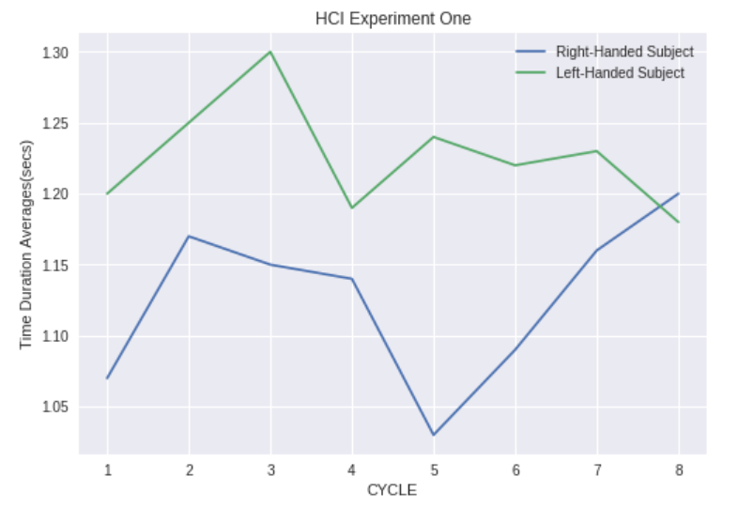

Fig. 12. Graph between average time duration for first eight cycles for right-handed and left-handed subjects using Matplotlib library of Python

It must be noted that this graph is not very reliable to conclude results as the data collected is limited. Nevertheless, if observed closely both the lines are the mirror image of each other which shows that the coordinates which are most easily accessible for a right-handed subject was the mirror image for the left-handed subject. Also, the average time taken by the right-handed subject to conduct the experiment is lower than what was taken by the left-handed subject.

Also, the experiment recorded the major and minor radius of eclipse formed by the subject during each of press and release events individually for each hand, right and left. The objective was to study if there is a pattern formed that would elicit the distinction of subject behavior when they use their dominant hand and when they use their other hand. It was found that there was no significant difference (in major) in press and release radius of the eclipse formed during a particular hit moment using a non-dominant hand compared to dominant hand. Hence it can be inferred that the subjects faced problem while using their non-dominant hand to hit a particular target as their press and release eclipse didn’t differ much, so the results suggest that subjects under test were not able to completely press the target using their non-dominant hand.

# CONCLUSION

The two important conclusions drawn from the data analysis are: the left-handed subjects were slower than the right-handed subjects and the index of difficulty measurement for handedness is a mirror image for the left-handed and right-handed subjects. As discussed earlier in the paper the data collected is not enough to strongly quote these conclusions.

For future work, data analysis using all the features must be completed for all the three experiments. Various features can be selected to be visualized using graphs to draw meaningful conclusions. Around twenty left-handed and right-handed subjects could be used to gather data of all three experiments to confirm the viability of the results. Experiment two must be modified to use a stair case selection rather than a single dropdown, because right now it’s not depicting the Steering law. More features could be recorded such as the device type (Android or Apple). Researchers can also study what all experiments can be added to the existing three experiments employed in this paper. Machine learning model can be employed further to discover the patterns in the data.

# REFERENCES

1. Arif, A. S., “A survey on mobile text entry handedness: How do users input text on handheld devices while nomadic?,” *2012 4th International Conference on Intelligent Human Computer Interaction (IHCI)*, pp. 1-6, 2012.
2. Cheng Zhang, Xiaohuan Li, Fang Gao, Fadong Zhou, Li Xu, “An Experimental Research on the Directivity of Fitts’ Law in Human-computer Interaction,” 2015 IEEE International Conference on Progress in Informatics and Computing (PIC), pp. 226-229, 2015.
3. Coakley, M. J., Monaco, J. V., & Tappert, C. C., “Keystroke biometric studies with short numeric input on smartphones,” *2016 IEEE 8th International Conference on Biometrics Theory, Applications and Systems (BTAS)*, pp. 1-6, 2016.
4. Lefyer, K., & Spivak, A., “Method of person identification based on biometric characteristics of touch screen gestures,” *2017 20th Conference of Open Innovations Association (FRUCT)*, pp. 1-7, 2017. Monaco, J. V., Bakelman, N., Cha, S.-H., & Tappert, C. C., “Recent Advances in the Development of a Long-Text-Input Keystroke Biometric Authentication System for Arbitrary Text Input,” *2013 European Intelligence and Security Informatics Conference*, p. 60-66, 2013.
5. Monaco, J. V., Bakelman, N., Cha, S.-H., & Tappert, C. C., “Recent Advances in the Development of a Long-Text-Input Keystroke Biometric Authentication System for Arbitrary Text Input,” *2013 European Intelligence and Security Informatics Conference*, p. 60-66, 2013
6. Sartarelli, Marcello, “Handedness, Earnings, Ability and Personality. Evidence from the Lab”, [*PLoS ONE*](javascript:__doLinkPostBack('','mdb~~aph%7C%7Cjdb~~aphjnh%7C%7Css~~JN%20%22PLoS%20ONE%22%7C%7Csl~~jh','');)*, pp. 1-17,* 2017.
7. Zheng, N., Bai, K., Huang, H., & Wang, H., “You Are How You Touch: User Verification on Smartphones via Tapping Behaviors,” *IEEE 22nd International Conference on Network Protocols*, pp. 221-232, 2014.
8. Zhong, Y., Deng, Y., “A Survey on Keystroke Dynamics Biometrics: Approaches, Advances, and Evaluations,” Recent Adv. User Authentication Using Keystroke Dyn. Biometrics, chapter 1, vol. 2, pp. 1–22, 2015.
9. Bakelman, N., Monaco,J. V., Cha, S.-H., and Tappert, C. C., “Keystroke Biometric Studies on Password and Numeric Keypad Input,” 2013 Eur. Intell. Secur. Informatics Conf., pp. 204–207, Aug. 2013.
10. Maxion, R. A., and Killourhy, K. S., “Keystroke Biometrics with Number-Pad input,” Proc. Int. Conf. Dependable Syst. Networks, pp. 201–210, 2010.
11. Bartlow, N., Cukic, B., “Evaluating the Reliability of Credential Hardening through Keystroke Dynamics,” 17th International Symposium on Software Reliability Engineering (ISSRE), pages 117–126, 2006.
12. Cho, S., Han, C., Han, D.H., and Kim, H.I., “Web-Based Keystroke Dynamics Identity Veriﬁcation Using Neural Network,”. Journal of Organizational Computing and Electronic Commerce, 10(4), pp. 295–307, 2000.
13. Giot, R., El-Abed, M., and Rosenberger, C., “Web-Based Benchmark for Keystroke Dynamics Biometric Systems: A Statistical Analysis”, Eighth International Conference on Intelligent Information Hiding and Multimedia Signal Processing (IIHMSP), pp. 11–15, 2012.
14. Haider, S., Abbas, A., and Zaidi, A.K., “A multi-technique approach for user identiﬁcation through keystroke dynamics,” IEEE International Conference on Systems, Man, and Cybernetics (ICSMC), volume 2, pp. 1336–1341, 2000.
15. Hosseinzadeh, D., and Krishnan, S., “GaussianMixture Modeling of Keystroke Patterns for Biometric Applications,” IEEE Transactions on Systems, Man, and Cybernetics, Part C: Applications and Reviews, 38(6), pp. 816–826, 2008.
16. Kang, P., Hwang, S., and Cho, S., “Continual Retraining of Keystroke Dynamics Based Authenticator,.” International Conference on Advances in Biometrics (ICB), vol. 4642 of LNCS, pps. 1203–1211, 2007.
17. Martono, W., Ali H., and Salami, M.J.E., “Keystroke Pressure-Based Typing Biometrics Authentication System Using Support Vector Machines,” International Conference on Computational Science and Its Applications (ICCSA), vol. 4706 of LNCS, pps 85–93, 2007.
18. Monrose, F., and Rubin, A.D., “Keystroke Dynamics as a Biometric for Authentication,” Future Generation Computing Systems, 16(4), pp. 351–359, 2000.
19. Yu, E. and Cho, S., “GA-SVM Wrapper Approach for Feature Subset Selection in Keystroke Dynamics Identity Veriﬁcation,” International Joint Conference on Neural Networks (IJCNN), vol. 3, pp. 2253–2257, 2003.
20. Zack, R.S., Tappert, C.C., and Cha, S.H., “Performance of a Long-Text-Input Keystroke Biometric Authentication System Using an Improved *k*-Nearest-Neighbor Classification Method,” 4th IEEE International Conference on Biometrics: Theory Applications and Systems (BTAS), pp. 1–6, 2010.
21. Zhou, X., “How Does the Subjective Operational Biases Hit the Steering Law,” 2012 IEEE International Conference on Computer Science and Automation Engineering (CSAE), pp. 654-658, 2012.

1.